gompz <-  flexsurvreg(Surv(t,flag) ~ 1,dist="gompertz",data=tmp)

ggamma <- flexsurvreg(Surv(t,flag) ~ 1,dist="gengamma",data=tmp)

rbind(gompz[c('AIC','loglik','npars')],

     ggamma[c('AIC','loglik','npars')])

     AIC      loglik    npars

[1,] 558.9885 -277.4942 2

[2,] 520.3229 -257.1614 3

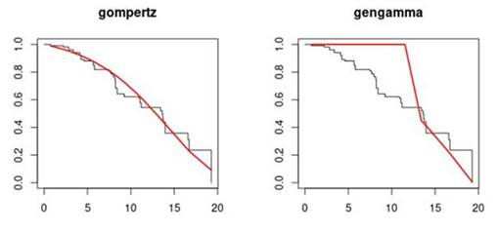

We found that a poorly fit generalized gamma have better AIC in comparison with other distribution like gompertz. It doesn’t give any warning message about convergence. I’ve enclosed a sample data to demonstrate this example.

It is common for the generalized gamma model to not converge. There are ways to try and make it converge. However, this involves making transformations to time which means that we then cannot compare it with other models using AIC and BIC.

However, I think this is more likely to be the error of plotting the predicted curve in R. We can discuss in more details today. Thanks